Letter of Invitation
162 Orange Grove Road,
Trincity,
Trinidad and Tobago, WI
16th March, 2018

To Whom It May Concern
- The Ministry of Planning and Development of Trinidad and Tobago (the “Borrower”) has received financing from the Inter-American Development Bank (IDB)(the “Bank”) toward the cost of Skills for Global Services Promotion Programme. Animae Caribe Festival, an executing agency of the Borrower, intends to apply a portion of the proceeds of this loan to eligible payments under the contract for which this invitation is issued. Payments by the Bank will be made only at the request of the Ministry of Planning and Development of Trinidad and Tobago and upon approval by the Bank, and will be subject, in all respects, to the terms and conditions of the loan contract.
- Animae Caribe Festival now invites individual consultants to provide services(hereinafter called “Services”) based on the Terms of Reference attached..
- It is not permissible to transfer this invitation to any other individual.
- An individual consultant will be selected under Individual Consultant Selection (3CV), procedures, in accordance with Section V of the Policy for the Selection and Contracting of Consulting Services financed by the IDB which can be found at www.iadb.org/procurement.
- Your expression of interest accompanied by your curriculum vitae should be submitted by 30th March, 2018, in writing at 162 Orange Grove Road, Trincity, Trinidad and Tobago, or by E-mail info@animaecaribe.com
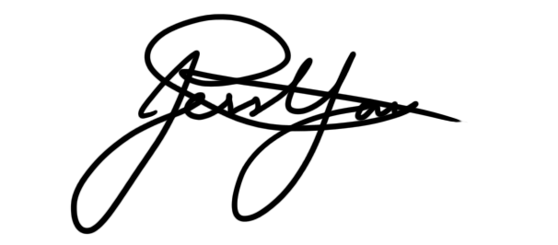
Yours sincerely,
_____________________
Jessica Yawching
Festival Coordinator,Project Lead
Animae Caribe Festival

Festival Office: 162 Orange Grove Road Trincity
www.animaecaribe.com info@animaecaribe.com 1 868 341 0383

